

|  |  |
| --- | --- |
|  | Laboratory Exercise 1: Hardness Mapping |
|  |  |
|  | Nguyen Xuan Binh (887799)  Talha Waqar (101561697)  Owais Ahmad (101738970) |
|  | MEC-E6007 Mechanical Testing of Materials  26/03/2024 |
|  |  |

Contents

1. Introduction 1

2. Methods 1

2.1 Materials and Instrument 1

2.2 Vickers Hardness Method: 2

3. Results 3

4. Discussion 3

5. Conclusion 5

6. References 6

Appendix 6

# Introduction

The field of material testing is a crucial part of engineering disciplines, as it offers crucial insights into the behavior and performance of materials under various conditions. Due to the challenges posed by environmental change and global sustainability, new materials are required. These new materials are then used in the next generation of products. For instance, in the maritime sector sustainability requires the effective use of high strength steels in the large, welded structures. In combination with new structural topologies the weight of cruise ships can be reduced considerably. However, during the manufacturing of these parts, the material properties change and there is a need to understand how these properties are affected. These new materials also require new and robust testing methodologies to explain and understand the changes that happened during manufacturing.

# Methods

## 2.1 Materials and Instrument

In this laboratory experiment, the effect of welding is studied on the material properties of the welded connection extracted from a real-world structure. S690 and S355 grade materials are welded together using submerged arc welding. A hardness test is conducted on the sample and the Vickers Hardness method is utilized. The Struers Duramin 40-AC2 testing machine with a diamond indenter is used with a dwell time of 10s for each test that is conducted. It has objective lenses on a rotating turret with different magnification and a motorized stage for the sample's movement.

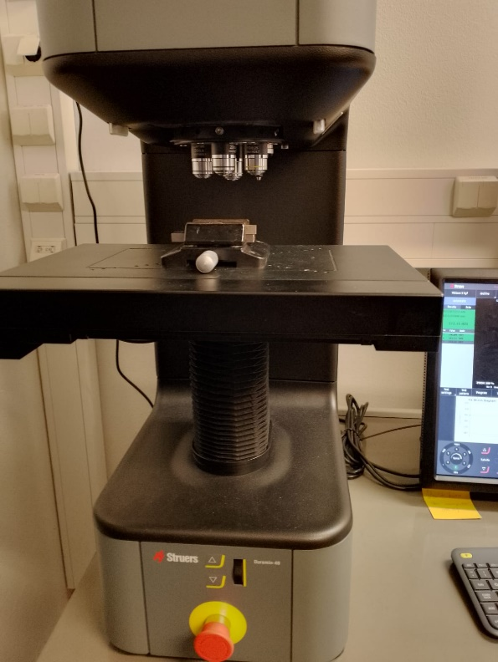 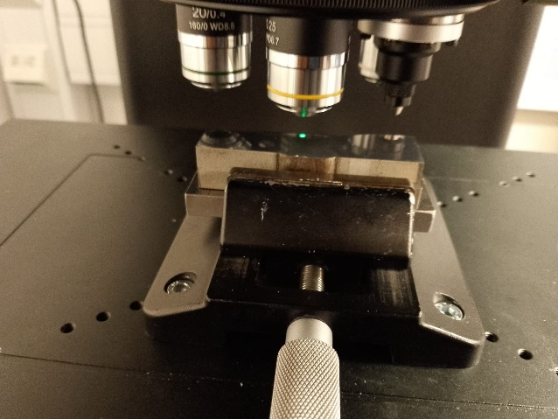

## 2.2 Vickers Hardness Method:

The Vickers hardness testing method is a widely used technique for measuring the hardness of materials. Named after its inventor, Smithson Tennant Vickers, this method involves indenting the surface of a material with a diamond-shaped indenter under a specific load. The size of the resulting indentation is then measured and used to calculate the material's Vickers hardness value.

**Formula for Vickers Hardness:**

The Vickers hardness value (HV) is calculated using the following formula:

Where,

$$HV = 1.854 ⋅ \frac{P}{d^{2}}$$

HV is the Vickers hardness value, P is the applied force (in kilograms-force, kgf), d is the mean diagonal length of the indentation (in millimeters, mm).

**Significance of Using Vickers Hardness Testing:**

The Vickers hardness method offers several advantages, including its ability to measure the hardness of a wide range of materials, regardless of their grain size, texture, or composition. Additionally, the diamond-shaped indenter produces well-defined, geometrically consistent indentations, allowing for accurate and reproducible measurements.

Furthermore, the Vickers hardness test is suitable for both micro-hardness testing (for thin coatings, surface layers, or small components) and macro-hardness testing (for bulk materials). This versatility makes it a valuable tool for material characterization in various industries, including aerospace, automotive, metallurgy, and manufacturing.

**Procedure:**

* The cutting of the part for the hardness test is performed using the EDM machine.
* Before conducting the hardness test, the material is carefully grinding, polished, and cleaned to remove any surface irregularities and obtain reliable results.
* The specimen is then clamped in place for the Vickers test, and the camera lens is focused on the material, util a clear picture of the specimen's surface is obtained in the display. This automatic focusing is done for all the different magnification provided by the Struers Duramin 40-AC2 testing machine. The magnification is changed through the use of the turrent to change to a different objective lens.
* After the autofocusing step is complete, a force value is selected for the test along with a test pattern along which the different number of indentations are to be performed and hardness value is measured. The test cycle is fully automated.
* A report is then generated by the operating system provided with the Struers Duramin testing machine.

# 

# Results

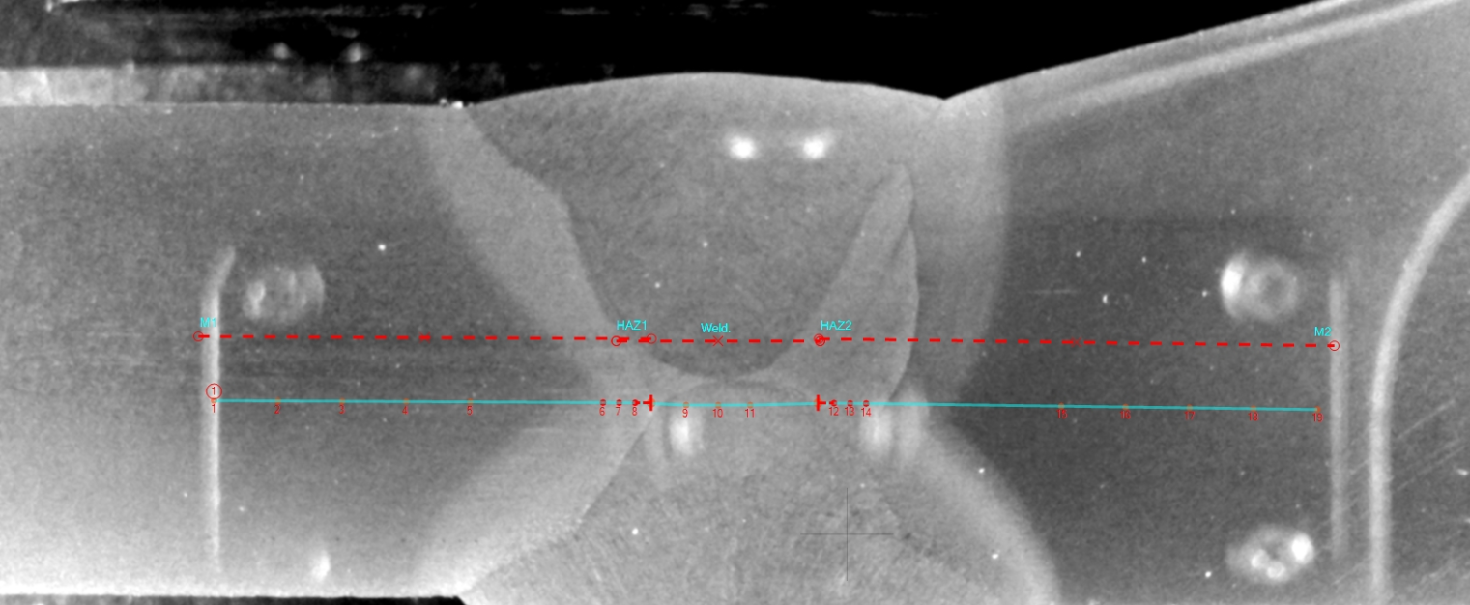

# Discussion

A Vicker’s hardness test was successfully performed on two dissimilar base metals with a

common welded V-butt joint. Both base materials were distinguished from each other, with the

left-hand side base plate being identified as the S355 grade steel plate and the right-hand side as

the S690 grade steel plate. Furthermore, possible sources of potential weaknesses in the weld

joints were classified as in the base materials, the weld joint and in the HAZs.

The variations in hardness across different regions of the sample could have implications for

its mechanical properties and performance in service. For example, the higher hardness of the

weld indicates greater resistance to wear and deformation in this area, which may be desirable

depending on the application. However, it's essential to consider other factors such as ductility,

toughness, and corrosion resistance in addition to hardness when assessing the overall

suitability of the material for its intended use.

In conclusion, the Vickers hardness test results provide valuable insights into the distribution

of hardness across different regions of the sample, highlighting variations that may influence

its mechanical behavior and performance. Further analysis and consideration of other relevant

factors are necessary to fully understand the implications of these findings.

The hardness variations in the welded specimen indicate the impact of welding on different steel

grades. S690 steel shows higher hardness compared to S355, highlighting their distinct

compositions. Heat-affected zones (HAZ) showed varied hardness, influenced by welding

parameters and cooling rates. Tempering effects were noticeable near base materials, affecting

hardness. Overall, this analysis underscores the complexity of welding-induced microstructural

changes and understanding these variations is crucial for optimizing welding procedures in practical applications.

The points of testing on the base metals (1-3 and 18-20) clearly indicate the relatively

homogenous hardness properties of the two separate metals being examined. The first

heat affected zone featured an unexpected outlier at point 5, showing the variability of

mechanical properties from the welding procedure.

Overall, the areas impacted by the welding process yielded lower hardness scores, and

the graph visibly demonstrates the weakness of the respective regions compared to the

two parent metals. Although the experiment didn’t fully follow the SFS-EN ISO 9015-2

standards, it followed them as loose guidelines, particularly noting the recommended

amount of test points per region. As a result, it's confident to say that this test would be

close enough to a similar test being carried out in an industrial setting.

This experiment effectively demonstrates the impact welding has on mechanical

properties of the two materials and portrays the drop in hardness in the area affected by

the process of welding.

# Conclusion

To sum up, the performed experiment shows that there are big consequences for mechanical properties of materials particularly hardness due to welding processes such as when we weld S690 and S355 grade steels. By implementing the Vickers hardness testing method, we have been able to successfully detect different levels of hardening ranging from the base metals through the weld zone up to heat affected zones.

The observed disparities in hardness between the parent metals and welded joints further demonstrates the complex microstructural changes induced by welding thus highlighting a need for a thorough comprehension of these variations to optimize procedures of welding while enhancing integrity and performance of weld structures.

Additionally, this experiment highlights why robust test methodologies should be used in material characterization thereby providing useful data on how materials behave under certain manufacturing conditions. Although it did not strictly follow conventional protocols, it is a practical reflection of actual situations and is meant to drive decisions regarding engineering choices for firms in various industries.

However, to fully explore the wider impact of welding-induced microstructural changes on other mechanical properties apart from hardness, such as ductility, toughness and corrosion resistance, more research and analysis is required in the future. This will help us become better at developing new materials and welding technologies that address changing needs in engineering fields across industries without compromising sustainability, productivity and safety.

# References

[1] W. Fricke, H. Remes, O. Feltz, I. Lillemäe, D. Tchuindjang, T. Reinert, A. Nevierov, W. Sichermann, M. Brinkmann, T. Kontkanen, B.

Bohlmann, L. Molter, Fatigue strength of laser-welded thin-plate ship structures based on nominal and structural hot-spot stress

approach, Ships Offshore Struct. 10 (2015) 39–44. https://doi.org/10.1080/17445302.2013.850208.

[2] H. Remes, P. Gallo, J. Jelovica, J. Romanoff, P. Lehto, Fatigue strength modelling of high-performing welded joints, Int. J. Fatigue.

135 (2020) 105555. https://doi.org/10.1016/j.ijfatigue.2020.105555.

[3] H. Remes, E. Korhonen, P. Lehto, J. Romanoff, A. Niemelä, P. Hiltunen, T. Kontkanen, A. Niemel?, P. Hiltunen, T. Kontkanen,

Influence of surface integrity on the fatigue strength of high-strength steels, J. Constr. Steel Res. 89 (2013) 21–29.

https://doi.org/10.1016/j.jcsr.2013.06.003.

[4] I. Lillemäe-Avi, S. Liinalampi, E. Lehtimäki, H. Remes, P. Lehto, J. Romanoff, S. Ehlers, A. Niemelä, Fatigue strength of highstrength steel after shipyard production process of plasma cutting, grinding, and sandblasting, Weld. World. 62 (2018) 1273–

1284. https://doi.org/10.1007/s40194-018-0638-y.

[5] H. Remes, J. Romanoff, I. Lillemäe, D. Frank, S. Liinalampi, P. Lehto, P. Varsta, Factors affecting the fatigue strength of thin-plates in large structures, Int. J. Fatigue. 101 (2017) 397–407. https://doi.org/10.1016/j.ijfatigue.2016.11.019

## Appendix